**Machine Learning: Assignment 10**

# 

# Submitted to:

Dr. Awais Hassan

# 

# Submitted by:

Komal Shehzadi (2020-MSCS-590)



**Discussion:**

Two code files are submitted for logistic regression one with automatic calculation and confusion matrix and other with manual calculation of weights and costs with confusion matrix and metrics discussed in class. Sklearn model is calculating slightly better results in terms of metrics discussed in class manual model is slightly less accurate on the given dataset of Social network ads. So it can be said that sklearn model is better it can be because of limitations of manual code like learning rate and number of iterations while sklearn model works randomly to calculate best suitable results and decision boundry.

**Sklearn model metrics:**

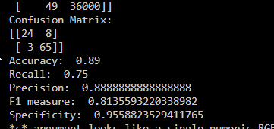

**Manual model metrics:**

